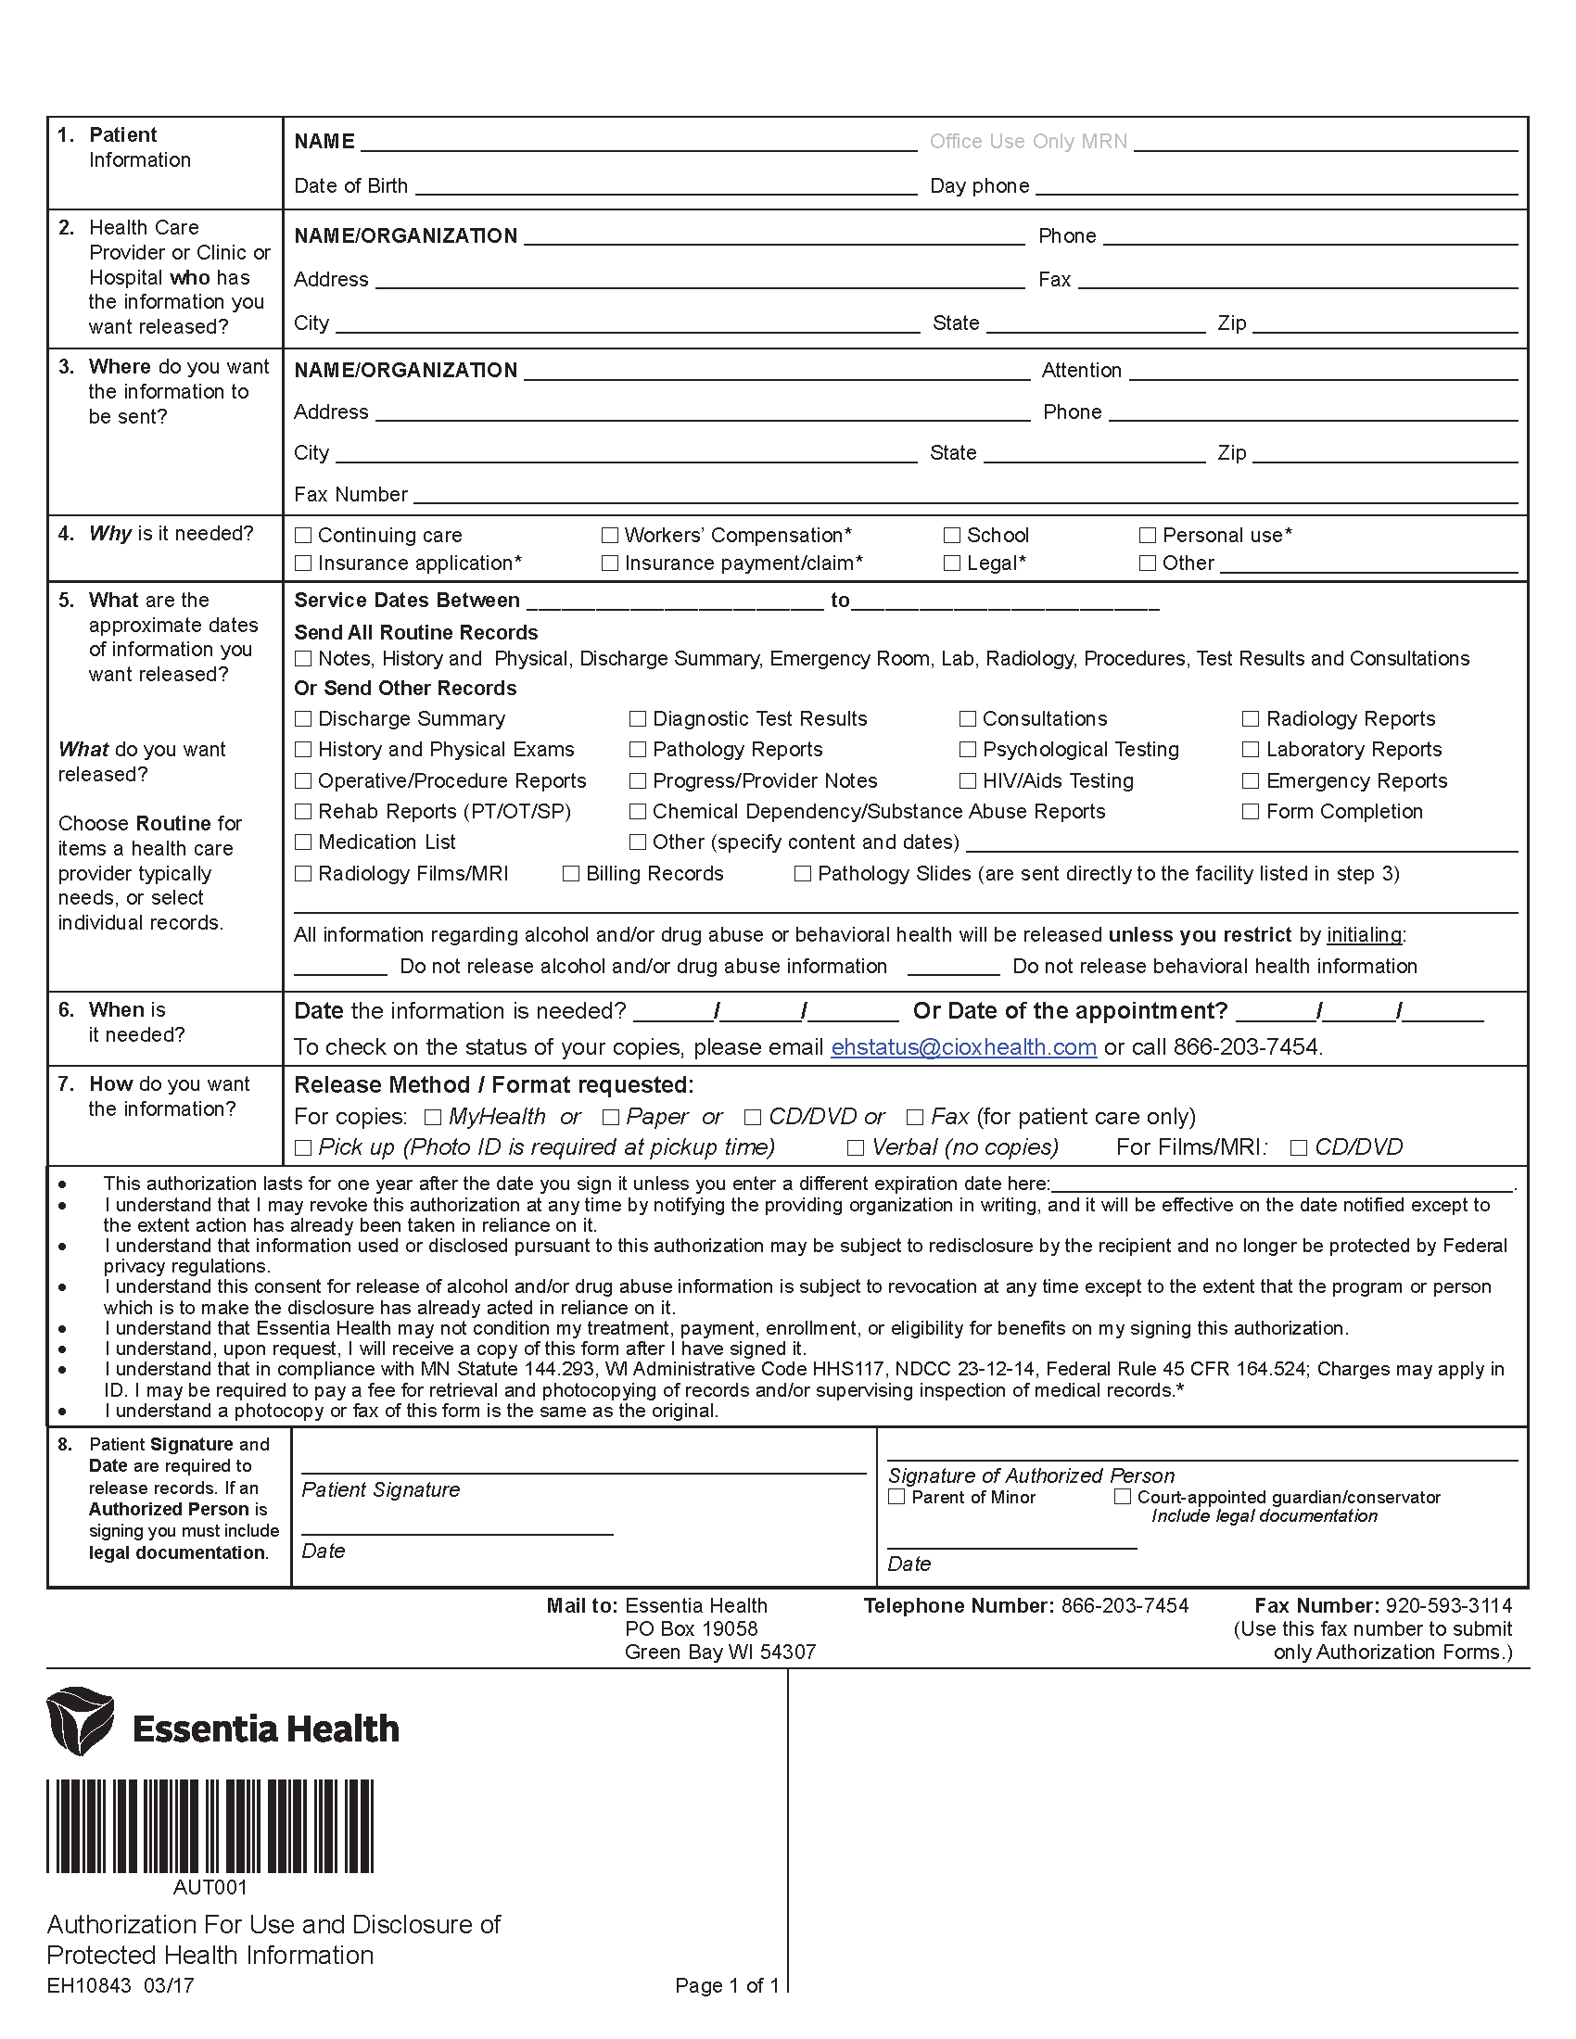
Batman
01/01/1979
University of Michigan Hospital and Health Center
(734) 936-5490
2901 Hubbard Street
Ann Arbor
MI
48109-0000
Axiom Requisition Copy Service
Records
2869 Jolly Road
(877) 886-5090
Okemos
MI
48864
(517) 886-4116
✓

FROM 01/01/1979 TO PRESENT: Any and all MEDICAL RECORDS, including but not limited to patient history form(s), reports, etc. pertaining to Batman SSN: xxx-xx-5555, DOB: 01/01/1979.
✓

